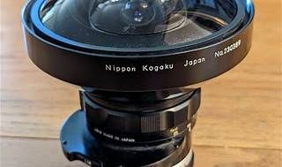

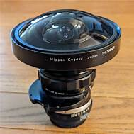

Explore

Certainly! In the realm of technology, a **fisheye lens** is an **extreme wide-angle optic** that captures a **distinctive and distorted view of the world**. [These lenses are used in both **stills photography** and **video recording**, providing a unique and often abstract perspective](https://nofilmschool.com/what-is-a-fisheye-lens-definiiton-example) [1](https://nofilmschool.com/what-is-a-fisheye-lens-definiiton-example)[2](https://www.digitalcameraworld.com/features/what-is-a-fisheye-lens-and-when-would-you-use-one).

Here are **five free learning resources** where you can explore more about fisheye lenses and enhance your tech skills:

1. **AI Singapore Student Outreach Programme**: This initiative promotes **AI literacy and proficiency** among students, offering practical experience in AI projects. [Completion of the program earns you industry-recognized certificates and even a **Google professional machine learning engineer certificate**](https://nofilmschool.com/what-is-a-fisheye-lens-definiiton-example) [3](https://www.tech.gov.sg/media/technews/new-year-new-tech-skills).
2. **SkillsFuture@NS Learning eXperience Platform**: Specifically designed for **national servicemen (NSFs)**, this platform provides **free unlimited access** to over **75,000 online courses**. [You can learn skills like **Python programming**, **machine learning**, and **digital photography**](https://nofilmschool.com/what-is-a-fisheye-lens-definiiton-example) [3](https://www.tech.gov.sg/media/technews/new-year-new-tech-skills).
3. **Coursera**: Coursera offers many courses for free, including those from renowned universities. [Explore topics like **machine learning**, **game theory**, and even **COVID-19 contact tracing**](https://nofilmschool.com/what-is-a-fisheye-lens-definiiton-example) [4](https://www.cio.com/article/221812/8-free-online-course-sites-for-growing-your-tech-skills.html).
4. **General Assembly**: While not entirely free, General Assembly provides some **free introductory courses** in tech-related fields. [It’s a great place to start your learning journey](https://nofilmschool.com/what-is-a-fisheye-lens-definiiton-example) [3](https://www.tech.gov.sg/media/technews/new-year-new-tech-skills).
5. **Explore and expand your knowledge**: Beyond formal courses, don’t hesitate to explore online tutorials, blogs, and forums. Websites like **Stack Overflow**, **GitHub**, and **Medium** offer valuable insights and practical tips.

Remember, these resources can help you dive deeper into the fascinating world of technology without costing you a dime! 🌟📚👩‍💻